**MAXIMIZING THE SALES OF AN AUTOMOBILE STORE**

**Final report for the BDM capstone Project**

Submitted by

Name: Anshika Tiwari

Roll number: 22F1000493



IITM Online BS Degree Program, Indian Institute of Technology, Madras, Chennai ,Tamil Nadu, India, 600036

**Contents**

1.Executive Summary and Title

2.Detailed Explanation of Analysis Process/Method

3.Results and Findings

4.Interpretation of Results and Recommendation

**Executive Summary and Title**

The aim of this project report is to Maximize the sales of an automobile store, named **“M.V. Motors”** located in Kanpur. The project describes the various analysis methods used during the business data analysis of “M.V. Motors” and the recommendations for the business to increase their sales. The store deals in the sales of EV scooters, automobile spare parts and also provide repairing services.

In this project, I have tried to used different steps during data analysis process like **data extraction, data cleaning, data visualization**. The main tool used for this process is MS Excel. Using these methods, I have tried to find the results, identify different problems and also identify the different reasons behind the problems faced.

During the interaction with the owner and the analysis process, a few problems were noticed, which the business was facing:

1. Low sales of EV Scooters
2. Overstocking
3. Market competition
4. Low revenue generated through repairing services
5. Old and unskilled staff

In this report, I have tried to provide the solutions of these problems faced by the business.

**Detailed Explanation Analysis Process**

**Steps of the Analysis process**

Approaching the Business

Data Collection

Data Cleaning

Data Manipulation

Descriptive analysis

Data Visualization

* I approached the automobile store business M.V. Motors for this project. After interacting with the owner of the store and the workers, I found a few problems that the business was facing. He had no issue in providing me the data of his business.
* The data was then collected from the business in pdf format. It was then converted into excel sheet. The data collected was the record of sales and purchases made by business over the period of 3 months.
* I organized and structured the data properly. The data was then cleaned as there were a few errors like spelling mistakes and missing values. The errors were corrected and the missing values were imputed using **“Fill Down”** method. Firstly, I filtered the data on the basis of the name of the product. Then I used Fill down method to fill the missing values.

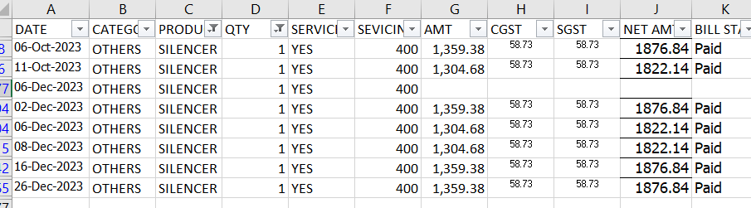

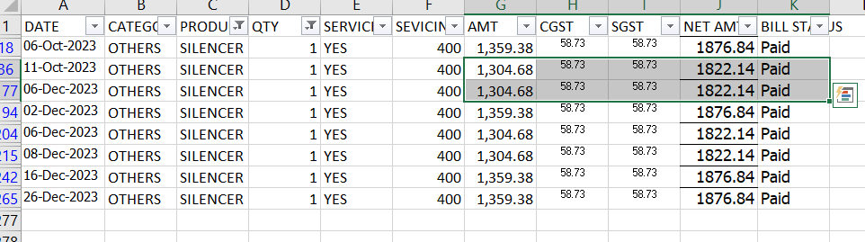

***Handling missing values using Fill Down method***

* After cleaning the data, I created **“Category”** column, to categorize different product on the basis of their categories.

For example, there were 3 different types of tyres being sold, so I categorized those tyres, rims and other such products in **“Tyres”** Category. Similarly, I categorized Backrest, Bike Guards, Helmets in **“Accessories”** category. I used **Filtering**, to filter the products and then I used **Fill-Down** method to categorize them.

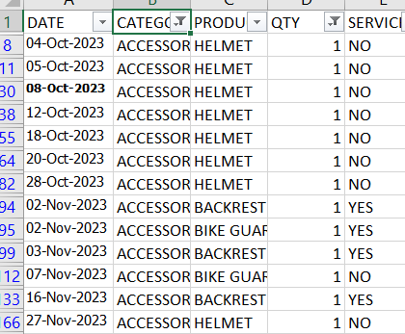

***Categorizing the data using Filtering and Fill down method.***

* After data cleaning and data manipulation, I performed various descriptive analysis. I used different **Pivot Tables** to for doing different computations. I computed values such as **Sum, Minimum, Maximum, Average and Standard Deviation.**

|  |  |  |  |  |  |
| --- | --- | --- | --- | --- | --- |
| **Categories** | **Sum of NET AMT** | **Average of NET AMT** | **Max of NET AMT** | **Min of NET AMT** | **Std Dev of NET AMT** |
| ACCESSORIES | 77854.32 | 1810.565581 | 2642.5 | 253.44 | 572.6455408 |
| BATTERY | 35464.72 | 1773.236 | 2130 | 1151.88 | 355.5710128 |
| BRAKES | 52786.62 | 1820.228276 | 2121.26 | 1304.22 | 229.4826187 |
| CLUTCH | 67958.13 | 1941.660857 | 2775 | 440.62 | 560.1362084 |
| ELECTRICAL | 39525.68 | 1796.621818 | 2249.22 | 525.32 | 441.4692866 |
| ENGINE | 28071.38 | 1871.425333 | 2114.36 | 1522.04 | 247.3512378 |
| OTHERS | 36476.88 | 3039.74 | 15865 | 1822.14 | 4039.250077 |
| SERVICING | 35000 | 686.2745098 | 1000 | 500 | 244.1471752 |
| TYRES | 103898.01 | 2210.595957 | 3950 | 1472.18 | 589.067825 |
| **Grand Total** | **477035.74** | **1741.00635** | **15865** | **253.44** | **1084.629757** |
|  |  |  |  |  |  |

|  |  |  |  |  |
| --- | --- | --- | --- | --- |
| **Months** | **Sum of NET AMT** | **Average of NET AMT** | **Max of NET AMT** | **Min of NET AMT** |
| **EV** | **525000** | **75000** | **75000** | **75000** |
| Oct | 150000 | 75000 | 75000 | 75000 |
| Nov | 225000 | 75000 | 75000 | 75000 |
| Dec | 150000 | 75000 | 75000 | 75000 |
| **Grand Total** | **525000** | **75000** | **75000** | **75000** |

***Pivot tables showing descriptive statistics***

* Like this, I made various pivot tables in different sheets for different types of analysis:

1. Analysis of the sales of EV scooters
2. Analysis of auto parts based on categories
3. Analysis of repairing services
4. Analysis of the purchase data
5. Analysis of different products sold
6. Daily revenue analysis

* I also used different types of data visualizing techniques for visualizing the data. For example, I used time series graph to see the trends in the sales over the period of 3 months. I also used “**Pareto chart”** for Pareto analysis.

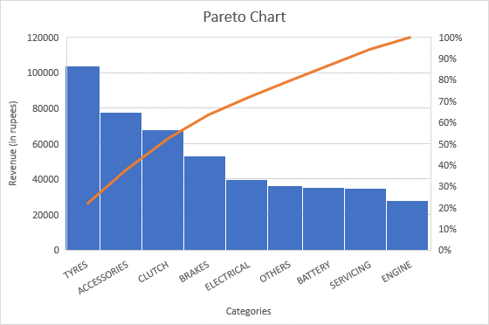

***Pivot chart showing Pareto analysis of categories v/s revenue generated***

* The main tool used for the data analysis process is MS Excel.

**Results and Findings**

* **Analysis of EV scooter’s sales:**

|  |  |
| --- | --- |
| **Months** | **Revenue of EV Scooter (in rupees)** |
| Oct | 150000 |
| Nov | 225000 |
| Dec | 150000 |
| **Grand Total** | **525000** |

***Monthly revenue generated through the sales of EV scooters***

***Pivot chart showing*** ***Monthly revenue generated through the sales of EV scooters***

The total revenue generated by the Sales of EV in 3 months is **Rs.525000.** If we look at the quantity sold, only 8 scooters were sold in the period of 3 months, which is quiet low. The most revenue was generated during the festive season in November.

* After performing the descriptive analysis, it was seen that the total revenue generated through the sales auto parts and repairing services was **Rs.477035.74** and through the sales of EV scooterswas **Rs.525000 .**
* **Daily Revenue analysis:** I tried to analyze the auto parts sales data on the basis of daily sales. I made the pivot table and visualized it using a **Time Series Graph**.

|  |  |
| --- | --- |
| **DATE** | **Sum of NET AMT (in rupees)** |
| **Oct** | **140441.655** |
| 02-10-2023 | 12304.955 |
| 04-10-2023 | 4802.32 |
| 05-10-2023 | 7222.2 |
| 06-10-2023 | 3876.84 |
| 07-10-2023 | 11120.92 |
| 08-10-2023 | 13016.74 |
| 11-10-2023 | 3952.14 |
| 12-10-2023 | 9315.26 |
| 13-10-2023 | 1643.44 |
| 14-10-2023 | 6239.16 |
| 16-10-2023 | 5024.08 |
| 18-10-2023 | 9057.82 |
| 20-10-2023 | 15618.76 |
| 21-10-2023 | 1151.88 |
| 23-10-2023 | 7851.94 |
| 24-10-2023 | 7132.18 |
| 25-10-2023 | 1876.54 |
| 26-10-2023 | 2239.06 |
| 27-10-2023 | 3739.06 |
| 28-10-2023 | 10840.32 |
| 29-10-2023 | 500 |
| 30-10-2023 | 1916.04 |

***Table showing daily revenue of auto parts in the month of October***

***Time series graph showing daily revenue of auto parts***

* **Category based analysis:** I tried analyzing the auto parts data on the basis of different categories of products sold. I made pivot tables for that with “**different categories” as rows** and “**sum of revenue”** and **“sum of quantity sold” as columns**.

|  |  |
| --- | --- |
| **CATEGORY** | **Sum of NET AMT (in rupees)** |
| ACCESSORIES | 77854.32 |
| BATTERY | 35464.72 |
| BRAKES | 52786.62 |
| CLUTCH | 67958.13 |
| ELECTRICAL | 39525.68 |
| ENGINE | 28071.38 |
| OTHERS | 36476.88 |
| SERVICING | 35000 |
| TYRES | 103898.01 |
| **Grand Total** | **477035.74** |

|  |  |
| --- | --- |
| **Category** | **Sum of QTY** |
| ACCESSORIES | 62 |
| BATTERY | 23 |
| BRAKES | 71 |
| CLUTCH | 45 |
| ELECTRICAL | 64 |
| ENGINE | 12 |
| OTHERS | 16 |
| TYRES | 59 |
| **Grand Total** | **352** |

***Pivot Tables for category based analysis***

***Pivot chart showing revenue generated for different categories of spare parts***

***Pivot chart showing the units sold for different categories of spare parts***

Here, we can clearly see that the **most revenue generating category is** **Tyres,** which generated, the total revenue of **Rs.103898.01**, while the **most selling category being brakes**, of which **71 units** were sold in 3 months.

* **Analysis of Repairing services:** To analyze the total revenue generated by repairing services, I made a pivot table, with months as rows and **“sum of servicing charges”** and **“count of services done”** as columns.

|  |  |  |
| --- | --- | --- |
| **Month** | **Sum of SERVICING CHARGES (in rupees)** | **Count of SERVICES DONE** |
| Oct | 31700 | 89 |
| Nov | 25950 | 84 |
| Dec | 20350 | 101 |
| **Grand Total** | **78000** | **274** |

***Pivot table for repairing services analysis***

It can be seen that the revenue generated by repairing services is gradually decreasing every month even though the count of services done is increasing.

I also made another pivot chart for analyzing the repairing services date by date.

***Pivot chart showing time series graph of revenue generated by repairing services***

Here we can see that, the maximum revenue generated through repairing services was on **20-10-2023.**The revenue generated was **Rs.4100**.

* **Purchase analysis:** I made pivot tables and charts to analyze the purchase data of the business.

|  |  |
| --- | --- |
| **Date** | **Amount purchased (in rupees)** |
| **Oct** |  |
| 15-Oct | 28740 |
| 25-Oct | 17050 |
| 27-Oct | 10168 |
| 31-Oct | 37570 |
| **Nov** |  |
| 01-Nov | 22504 |
| 16-Nov | 17425 |
| 17-Nov | 20934 |
| 21-Nov | 5430 |
| 22-Nov | 5833 |
| 28-Nov | 4900 |
| 29-Nov | 6525 |
| **Dec** |  |
| 01-Dec | 42265 |
| 03-Dec | 6612 |
| 06-Dec | 17725 |
| 09-Dec | 14600 |
| 11-Dec | 28770 |
| 13-Dec | 10964 |
| 14-Dec | 20138 |
| 22-Dec | 40110 |
| 24-Dec | 10400 |
| 25-Dec | 6660 |
| 28-Dec | 19477 |
| **Grand Total** | **394800** |

The maximum purchase was made on **01-12-2023,** for **Rs.42264.**

***Pivot table and pivot chart showing time-series analysis of the purchases made by the store***

|  |  |
| --- | --- |
| **Row Labels** | **Sum of Amount (in rupees)** |
| AMAR MOTORS | 44822 |
| DEEP AUTOMOBILES | 35150 |
| K.K. ENTERPRISES | 20138 |
| KAMADGIRI ENTERPRISES | 211322 |
| R.R.& SON'S | 22504 |
| SAMAY SHATABDI POWER SOLUTIONS | 60864 |
| **Grand Total** | **394800** |

***Pivot table showing supplier v/s amount purchased***

***Pivot chart showing supplier v/s amount purchased***

The maximum purchase was made from the supplier **Kamadgiri**

**Enterprises,** which was **Rs.211322.**

* **Analysis of products sold:** After analyzing the sales of all the auto parts sold, we saw that the most revenue generating product was **Tyre of second type**. The total revenue generated by it for the period of 3 months was **Rs.48123.36.**

***Pivot chart showing revenue generated by different products***

***Pivot chart showing revenue generated by different types of Tyres***

The most revenue generating accessory is **Helmet**, which generated revenue of **Rs.30651.66** in the period of 3 months.

***Pivot chart showing revenue generated by different accessories***

**Link for the workbook:**

<https://docs.google.com/spreadsheets/d/14U_8NZy7wZSaYQ3ex-APUoNvHNvKCfkk/edit?usp=drive_link&ouid=101692695088928596840&rtpof=true&sd=true>

**Interpretation of Results and Recommendations**

* It was noticed from the analysis that the sales of EV scooters was the most during the festive season. To increase the sales, the shop can give different offers to the customers on the purchase of scooters. For example:

1. **Free servicing for 1 year on the purchase of EV Scooter**
2. **Free Helmet on the purchase of EV Scooter.**

* Providing free helmets is also a good alternative to overcome the problem of overstocking, as it was seen that many helmets were overstocked.
* During my visit to the store, I also noticed that they don’t take any servicing charges if there is minimal to no problem in the vehicle. To increase the revenue generated by servicing, they should start taking servicing charges for checking up the vehicles, even if there is no problem found.
* Market Competition is one of the main reasons for the low sales of the business as there are many automobile stores in the same area. To stand out, there are a few recommendations:

**1. Doorstep servicing**: They should start providing doorstep services to their customers by sending their staff to the customer’s place.

**2. Online Presence**: They should also start promoting their business online, this will help them in standing out in the competitive market.

* During the Pareto analysis, it was seen that the most revenue is generated through the categories**: Tyres, Accessories and Clutch**. To increase the revenue, they should try selling and promoting more of these categories during servicing.

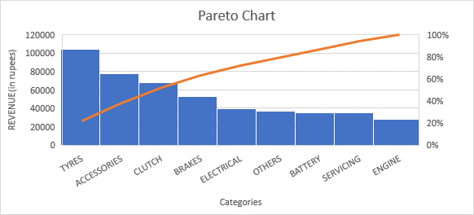

***Pareto chart for analysis of most revenue generating categories of spare parts***

* They should try to replace the old staff by new and more skilled workers.
* It was noticed that on many days the store was closed as the owner was out of the city. This has clearly affected the sales of the store. It is recommended that they should hire a person who could supervise and manage the store properly.